Four pillars of OOP(Python)

There are four pillors of OOP
- Inheritance
- Encapsulation
- Abstraction
- Polymorphism

- Abstraction
- It hides internal implementation
- Shows only the essential features
- It focus on “what it does” not on “how it does it”
- Exapmle:

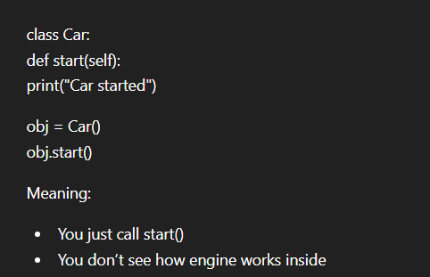
WE will study it later in detail

